Title of Manuscript, 12 pt. Times New Roman font

John Surname¹, Esther Surname² and Author Three³,* (11 pt. Times New Roman)
¹ Affiliation (8 pt. Times New Roman), ² Affiliation (8 pt. Times New Roman),
*Corresponding Author: email address@national-u.edu.ph

Abstract: A brief summary of approximately 250 – 300 words outlining the background, objectives of the study, the methodology used, key results and conclusions. Manuscripts must be submitted as Word files using the prescribed format. Use Times New Roman, 10 pt., justified. Save the manuscript as MS word document.

Keywords: up to five key words/terms; separated by semicolons (Times New Roman, 10 pt.)

1. INTRODUCTION
1.1 Subsection
Main text/Content font: Times New Roman Font size: Section (11 pt), subsection (11 pt), Sub-subsection (11 pt), Main text (1 pt). For the main text (contents) and references, one column formatting is required. In general, papers will have sections for the introduction, methodology, results and discussions, acknowledgements and conclusions. However, authors may exercise some flexibility in organizing the content of their papers. The paper should be formatted with 1-inch side margins, 1.5-inch top margin and 1-inch bottom margin in 7”x10” size. The whole paper should be singles-paced and justified. The introduction should give a brief background of the study, describe relevant developments in the literature to date, and describe the objectives and scope of the study. Indent paragraphs by 0.5-inch.

2. METHODOLOGY
Figures and tables should be referred to in the text. They should be centered as shown below and must be of good resolution. Where equations are used, adequate definition of variables and parameters must be given, as shown in the example below.

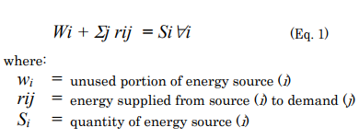

3. RESULTS AND DISCUSSION
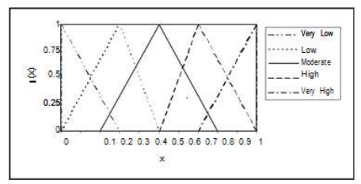
Results should be discussed thoroughly but concisely in this section with the aid of figures and tables whenever necessary.
Fig. 1. Captions should be 11 pt., Times New Roman, “Tight” Text Wrapping

Text within tables should use 9 pt. Time New Roman font, as shown in the example below. Tables should as much as possible occupy only one column page. Table headings should be re-indicated for catenated tables.

Table 1. Sample table format
Energy Resource | Emission Factor | Available Resource | Expected Consumption
Coal | 105 | 600,000 | 1,000,000
Oil | 75 | 800,000 | 400,000
Natural Gas | 55 | 200,000 | 600,000
Others* | 0 | >400,000
Total |  | >2, 000, 000 | 2, 000, 000

Citations should be in this format, APA style (Adamo, 1980; Chen and Hwang, 1992; Tan et al., 2005). They should be listed at the end of the paper in alphabetical order.

4. CONCLUSIONS
This section must summarize the key findings of the study and describe potential areas for further research.

5. ACKNOWLEDGMENTS
Please acknowledge funding sources, collaborators or anyone who has helped in the completion paper at the end of the text.

6. REFERENCES (use APA style for citations)
Berkowitz, R. T., Wadden, T. A., Tershakovec, A. M., & Cronquist, J. L. (2003). Behavior therapy and sibutramine for the treatment of adolescent obesity [Electronic version]. Journal of American Medical Association, 289, 1805-1812.
Carmona, R. H. (2004, March 2). The growing epidemic of childhood obesity. Testimony before the Subcommittee on Competition, Foreign Commerce, and Infrastructure of the U.S. Senate Committee on Commerce, Science, and Transportation. Retrieved from http://www.hhs.gov/asl/testify/t040302.html
Crtiser, G. (2003). Fat land: How Americans became the fattest people in the world. Boston: Hougton Mifflin.
Duenwald, M. (2004, January 6). Slim pickings Looking beyond ephedra. The New York Times, p. F1. Retrieved from LexisNexis.

